**Final Writeup (Phase III):**

**Evaluating Factors of Rental Listing Quality**

Kevin Liu, Rohit Jagga

November 30, 2022

## 1. Research Question

Which factors of a short-term rental listing are most important in determining its quality, and how are they influenced by external factors like crime or trends in the housing/rental market?

## 2. Background and Motivation

Short-term rentals have experienced a substantial growth in popularity in recent years as a cheaper alternative to hotels. This growth has been spearheaded by Airbnb, a company that provides a marketplace for short-term rental services, typically through homesharing.

As of 2022, Airbnb has grown to include over 7 million listings in 100,000 cities around the world. As such, Airbnb listings can be found in a wide variety of environments, so different users may report different quality of experience depending on their rental’s environment.

To understand the desirability and profitability of their listings, it is important for Airbnb hosts to consider the factors that could influence the listings’ quality. For example, the level of crime in the neighborhood could be a key differentiating factor between two listings that would otherwise be similar. Thus, evaluating the influence of these factors could help Airbnb hosts not only assess the current quality of their listings but also gain insight into what kinds of changes to these factors would best improve this quality.

At a larger scale, the effects of these factors may also vary by region - for example, Airbnb users in New York City may value certain properties of a listing more than Airbnb users in Chicago. Moreover, these effects may also vary over time, potentially as a result of overall trends in the housing and rental markets. Then, Airbnb hosts could also benefit from considering these macro-level effects of space and time when evaluating their listing’s quality.

Therefore, the goal of this project is to (1) determine which factors may influence the quality of Airbnb listings and (2) assess the role of external factors in affecting this quality. Our results could help Airbnb hosts better understand the underlying influences of listing quality and potential ways of improvement. In addition, these results could provide an explanation for differences in the behavior of short-term renters across space and time.

## 3. Hypotheses

Our null hypothesis is that the details of a short-term rental listing are not related to the quality of the listing (as represented by its reviews), and that external factors do not play a significant role in explaining variations in listing quality.

Our overall alternative hypothesis is that the features of a short-term rental listing, such as location, availability, price, description, etc. are in fact an important factor in the quality of the listing evaluated by its reviews. Characteristics of a listing such as crime rates and larger market trends are also influential in the reviews a listing receives. Our alternative hypothesis can further be broken down into more specific hypotheses:

* Positive sentiment in the listing’s & locale’s description are indicative of a higher-quality rental listing.
* A rental listing with higher pricing, larger accommodations will have better reviews.
* A rental listing with more availability will have worse reviews (being less booked out might imply that people are not rushing to book it due to lower perceived quality).
* Listings in areas with lower crime rates will have better reviews.

## 4. Methodology

Since the “quality” of a short-term rental listing is a subjective measure, we intend to use the listing’s average rating by reviewers as a proxy for quality, while acknowledging that other considerations such as profitability, maintenance, etc. may also be important for owners when they are evaluating the quality of their listings.

The first section of our analysis for this project will revolve around conducting a multiple linear regression of the direct factors, with independent variables being various features of a listing (such as location, availability, price, description, etc.) and the dependent variable being the average reviewer rating of the listing. In the second section of our analysis, we plan to extend this to incorporate external features such as crime rates, hotel price indices, etc. while focusing on specific geographic regions and timeframes (listings from the New York City and San Francisco areas over the past year), so that we can perform a more comprehensive analysis of the correlations between different features, and examine how the relative importance of a listing’s features varies across different regions of the area (with a supporting geographic visualization). Finally, we combine these analyses and their features into “combined” regression models, which helps us compare the relative effects of these features in explaining listing quality.

As part of the process for conducting our multiple regression analysis in section 1, we perform sentiment analysis on the content of the owner’s listing description and owner’s area description. The sentiment analysis is done using Python’s NLTK package, and involves parsing the text descriptions into tokens, removing stopwords, and computing the polarity & subjectivity scores of the resulting list of tokens via NLTK’s sentiment analyzer. Then, the polarity score (the main measure of a text’s positive or negative sentiment) is fed in as an input feature for the linear regression, with the subjectivity score also serving as an input feature if relevant.

In addition to the exploration of listing-specific features for a given region, we will also more broadly examine how external factors influence listing quality in section 2. This allows us to incorporate additional data such as crime rates, hotel prices, housing market valuations, etc. to evaluate the influence of these external factors on a listing’s quality. Specifically, we intend to focus on crime rates, average hotel prices (from the Trivago Hotel Price Index), and average housing prices (from the Zillow Home Value Index) as the main external factors we are considering, due to the accessibility of this data in a centralized format.

## 5. Data Sources

* [Quarterly Data by Region](http://insideairbnb.com/get-the-data) (Airbnb): This data source provides quarterly data for the last 12 months of each region. Each region (city) is associated with the following datasets: *listings.csv* (listings data), *calendars.csv* (calendar data), *reviews.csv* (reviews data), and *neighbourhoods.csv* (neighborhoods data). These datasets provide information about the features of short-term listings, which form a key component of our regression analysis.
* [NYPD Complaint Data Current](https://data.cityofnewyork.us/Public-Safety/NYPD-Complaint-Data-Current-Year-To-Date-/5uac-w243) (City of New York): This dataset contains all crimes reported to the NYPD in 2022 (through September). It provides information about crimes in various neighborhoods, which allows us to incorporate external crime-related variables into our analysis.
* [San Francisco Police Department Incident Reports](https://data.sfgov.org/Public-Safety/Police-Department-Incident-Reports-2018-to-Present/wg3w-h783) (City and County of San Francisco): This dataset contains all crimes reported to the SFPD from 2018 to present (November 2022). Like the NYPD data, it provides information about crimes in various neighborhoods.
* [San Francisco Analysis Neighborhoods (2010 US Census Tracts)](https://data.sfgov.org/Geographic-Locations-and-Boundaries/Analysis-Neighborhoods-2010-census-tracts-assigned/bwbp-wk3r) (City and County of San Francisco): This dataset contains 2010 US Census data on the populations of each neighborhood in San Francisco, which are used along with crime data to calculate crime rates.
* [Zillow Home Value Index Data](https://www.zillow.com/research/data/) (Zillow): This dataset contains smoothed, seasonally adjusted time series data (monthly, since 2000) of the Zillow Home Value Index (ZHVI) at the city level. The ZHVI “reflects the typical value for homes in the 35th to 65th percentile range.” The ZHVI will be used as a feature in our regression analysis, which may provide additional insight into variations in short-term rental quality.
* [Trivago Hotel Price Index Data](https://businessblog.trivago.com/trivago-hotel-price-index/) (Trivago): This data source contains monthly Trivago hotel price indices in the last 12 months for major global cities. The hotel price index will be used as a feature in our regression analysis, which may provide additional insight given that hotels form a primary alternative to short-term rentals.

## 6. Direct Model

### 6.1. Data Collection & Preprocessing

The primary data we used for the direct regression analysis was the Airbnb listings & reviews data, which we decided to include for the 31 given U.S. cities/regions (excluding international cities from the Airbnb dataset). To do this, we randomly sampled 15% of the listings data from each city/region, and then sampled 5% of the associated reviews data. This was necessary as some of the datasets for each individual region were >400 MB in size, so the sentiment analysis and regression model would have exceeded our computational limits on Colab had we included the full data from each region. Each region’s listings were appended to the total listings dataframe and the customer reviews were appended to the total reviews dataframe.

Relevant columns from the reviews dataset were: “listing_id”, “date”, “reviewer_id”, & “comments”. The primary columns of interest from the listings dataset were the “review_scores_rating” (scale of 0-5, used as the main dependent variable for our regression analysis), “price”, and several direct features of the listing (i.e. “room_type”, “amenities”, “instant_bookable”) that we made a decision on whether or not to include in our final regression model.

Before we could conduct our sentiment analysis & regression model, preprocessing needed to be done for several columns of the data that couldn’t yet directly be used as features in the regression. For instance, values in the price column needed to be stripped of $ symbols & commas to be converted to floats, the “host_response_rate” and “host_acceptance_rate” columns needed to be stripped of % symbols to be converted from percentages to floats, and binary true/false columns such as “host_identity_verified” needed to be encoded as ‘1’ or ‘0’ values to be used in the regression model.

For categorical variables such as room_type (which could be one of the four groups [“Entire home/apt” | “Private room” | “Shared room” | “Hotel”]), we initially attempted to use one-hot encoding (i.e. creating dummy variables for each category type). However, this drastically enlarged the space requirements of our dataframe due to the # of types for certain categorical features, so we instead decided to make use of the statistical formula format (i.e. specifying “C(room_type)” in the regression model) allowed by the statsmodels package’s OLS regression model, which handles one-hot encoding for categorical variables under the hood.

### 6.2. Sentiment Analysis of Reviews

To quantify the sentiment of the comment reviews for each listing, we conducted a sentiment analysis on the reviews text data using Python’s NLTK & TextBlob modules. We later expanded the sentiment analysis for the text data from the listing’s “description” & “neighborhood_overview” columns as well, since these columns are intended to be descriptive text explanations given by the listing owner to advertise the listing to potential renters.

The sentiment analysis primarily involved preprocessing the text data from each review to clean up formatting/punctuation, remove stopwords, and then compute a measure of the text’s polarity and subjectivity scores.

* The polarity metric ranges from [-1, 1], where -1 defines a strongly negative sentiment and +1 defines a strongly positive sentiment.
* The subjectivity metric quantifies the amount of personal opinion and factual information contained in the text, and ranges from [0, 1]. A subjectivity value close to 0 indicates a high degree of factual information/objectivity, whereas a value close to 1 indicates that the text contains mostly personal opinion and is highly subjective.

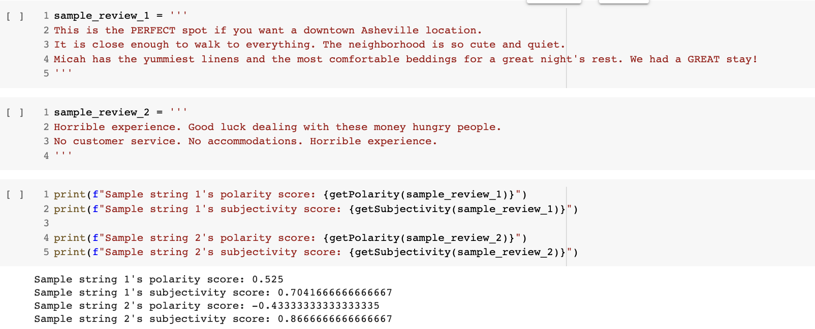

Shown above are the results from the polarity & subjectivity metrics applied to two example comment reviews from the Asheville, NC region. We see that “sample_review_1” is highly positive about the listing and includes some information about the neighborhood/listing details, which is reflected in the 0.525 polarity score (positive sentiment) and 0.704 subjectivity score (relatively subjective). On the other hand, “sample_review_2” is highly critical of the listing and essentially just rants about the negative personal experience, which is reflected in the -0.433 polarity score (negative sentiment) and 0.867 subjectivity score (very subjective, as there is little to no objective information conveyed in the review).

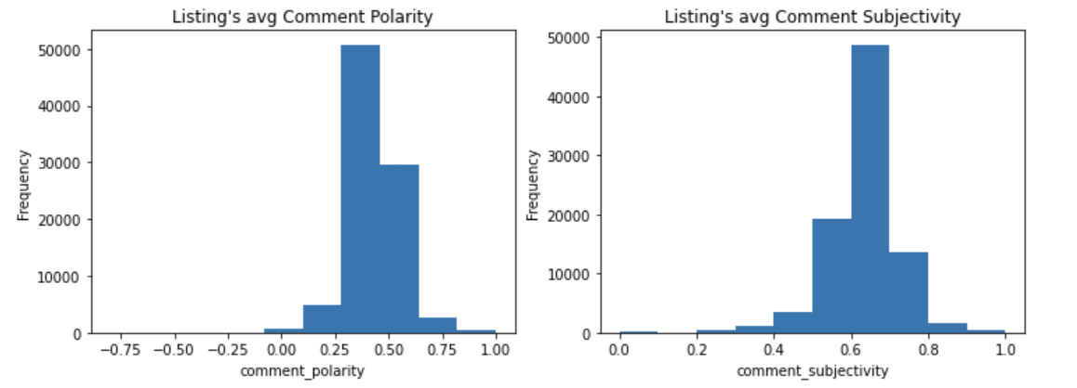

Looking at the overall distribution of the reviews’ polarity and subjectivity scores above, we see that the review comments’ polarity scores primarily fall between 0.25 - 0.5, indicating that comments with moderately positive sentiment make up the majority of reviews. The review comments’ subjectivity scores primarily fall between 0.5 - 0.8 with a peak of ~0.65, indicating that most comments have a relatively high degree of subjectivity and that mostly objective comments are in the minority.

The sentiment analysis results from the text data were incorporated into our overall regression model by computing two new columns (polarity & subjectivity scores) for each listing, and taking the average for both sentiment analysis metrics over the group of reviews associated with the specific listing (identified by performing a merge on the listings & reviews dataframes based on “listing_id”).

### 6.3. Analysis of Listing Features in the context of Sentiment scores

Before setting up the linear regression model based on the listing features, we did some further analysis on the relationship between various sentiment score components and the listings’ reviews. For instance, after looking at the calculated “comment_polarity” & “comment_subjectivity” columns (from sentiment analysis section) in relation to the overall “review_scores_rating” values, we saw that both the “comment_polarity” and the “comment_subjectivity” seem to display a moderately positive relationship with the “review_scores_rating”.

These relationships are shown in the two joint plots below, and may be explained by the idea that renters who leave more subjectively positive reviews for a listing are more likely inclined to do so for listings that they rate more highly across all rating categories.

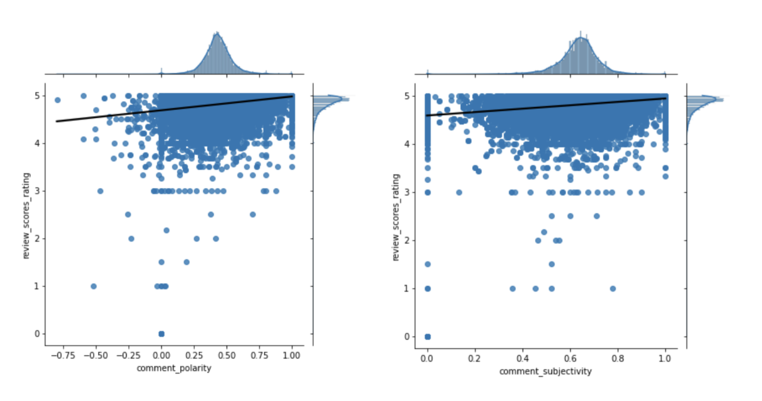

We also decided to look further into the sentiment metric components that we would expect to be highly correlated with certain subcomponents of the “review_scores_rating”. For instance, we expected that “neighborhood_polarity” scores (a measure of the positive/negative sentiment in the listing owner’s description of the surrounding neighborhood) should be somewhat correlated with the “review_scores_location” values (a component of the overall review score that is specifically focused on the listing’s location). A slight positive relationship between these two was indeed reflected in the data, as shown in the graph below.

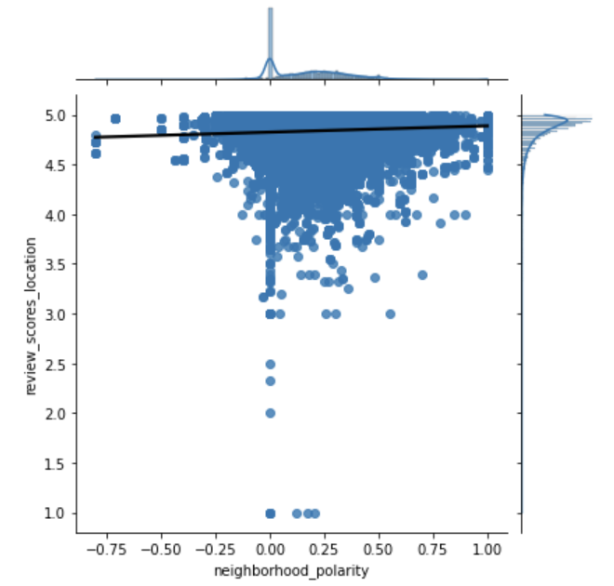

### 6.4. Regression Model (from listing’s direct features & sentiment scores)

Then, after calculating the sentiment scores from the review comments, listing’s description, and listing’s “neighborhood_overview”, we then proceeded to perform a regression analysis with “review_scores_rating” as the dependent variable and the listing’s key direct features & sentiment metrics as the set of independent variables. We ended up including the following groups of relevant features from the listing’s direct data & sentiment metric columns:

* “host_response_time”, “host_response_rate”, “host_total_listings_count”, “host_identity_verified”
* “room_type”, “amenities”, “accommodates”, “availability_365”, “instant_bookable”, “price”
* “number_of_reviews”, “comment_polarity”, “comment_subjectivity”, “neighborhood_polarity”

We believe that the first group of features was relevant in helping to explain the host’s reliability in offering a positive rental experience. The second group of features represents some of the key characteristics of the listing itself, and aspects of the rental that directly contribute to the renter’s booking experience (i.e. “amenities”, “instant_bookable”). The last set of features were the sentiment metric scores we deemed to be most relevant to explaining the quality of the rental. Other features calculated from our sentiment analysis such as “neighborhood_subjectivity”, “description_subjectivity”, etc. were excluded from the model on the basis of low significance (from feature’s t-test scores).

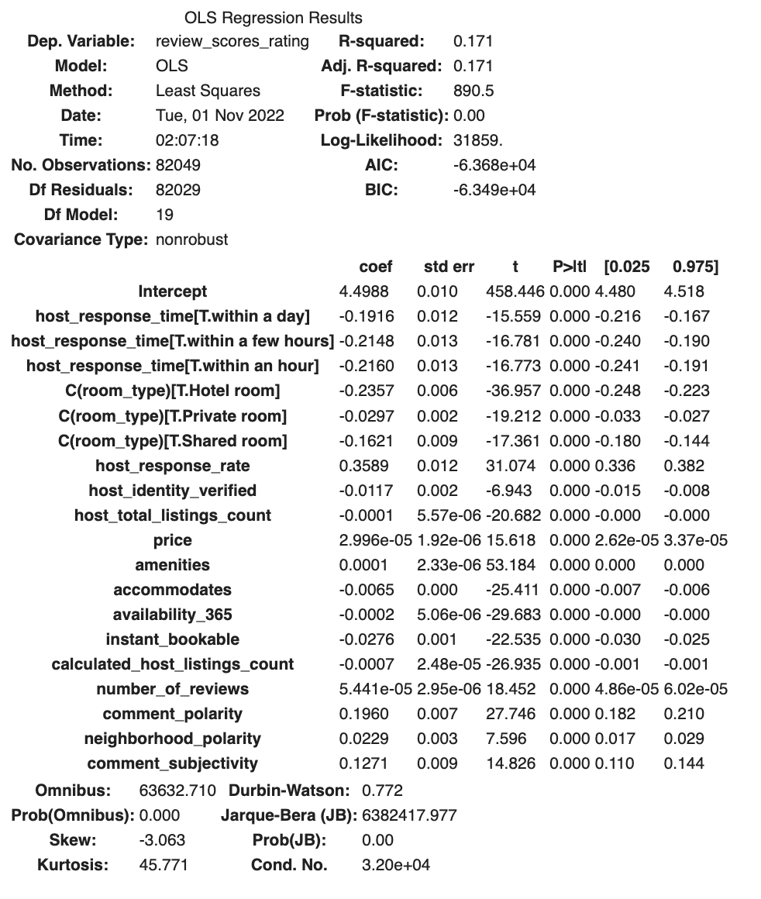

The summary results from our final regression model are displayed above. Note that “host_reponse_time” and “room_type” are categorical variables. Also note that the overall regression model displayed a relatively weak correlation (R-squared value of 0.171). It appears that the set of features we included were significant in the overall model, but we would conclude that these features help indicate the presence of a general relationship to the “review_score_rating”, but that there are likely other factors/considerations at play that are affecting the overall relationship as well.

## 7. External Model

### 7.1. Data Collection & Preprocessing

Our regression analysis for external factors used data from Airbnb listings, New York crimes, San Francisco crimes, Zillow, and Trivago. In particular, we constructed separate regression models for New York and San Francisco in order to compare the relationship observed for these two cities.

For each city, we considered two dependent variables from the Airbnb listings data: average overall review score and average location review score, which fall on a scale from 0 to 5. The figure below shows the distribution of these two variables (for both cities), which primarily fall between 4 and 5 (the maximum) and are very similar.

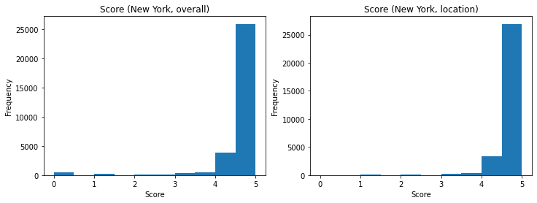

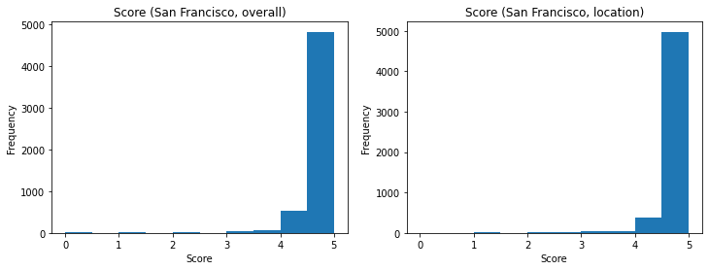

In general, each dataset can be grouped by one or more of the following categories:

* Date: In the Airbnb data, we took the “date” of a listing to be the date of its last review. In the New York data, we took the “date” of a complaint to be the starting date of the occurrence. The Zillow and Trivago data already grouped the data by month. When working with all datasets simultaneously, we considered only the month and year components of the Airbnb and New York/San Francisco dates for compatibility with the Zillow and Trivago data.
* Borough (New York only): The Airbnb and New York data list the boroughs of each entry (Bronx, Brooklyn, Manhattan, Queens, and Staten Island). We use this as the main regional categorization for the New York data.
* Neighborhood (New York and San Francisco): The Airbnb and Zillow data list the neighborhoods of each entry, which are more specific than the boroughs in the case of the New York data. We use this as the main regional categorization for the San Francisco data.

### 7.2. Crime Rate

We first considered the effect of crime rate on the scores of Airbnb listings in New York and San Francisco. To measure crime rate, we computed the number of complaints in 2022 per 100,000 people for each city region (boroughs for New York and neighborhoods for San Francisco) and compared them to the average score (overall and location) of listings associated with those regions. (We used US Census data to determine the regional populations.) The results for both cities are shown in the figure below.

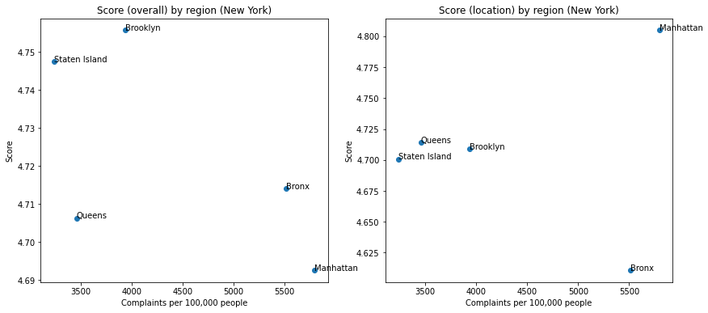

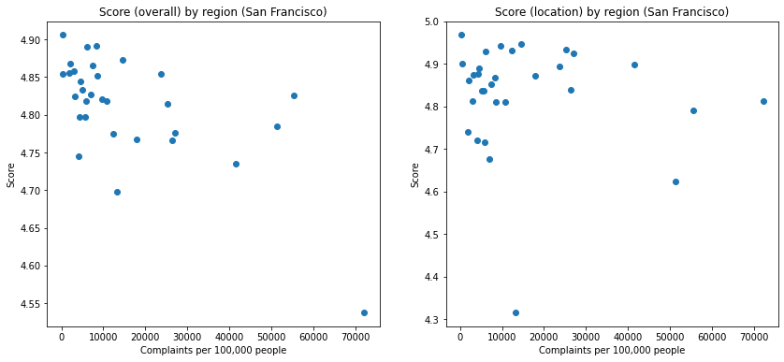

We see for both cities that higher crime rate was generally correlated with lower overall scores, although there was no conclusive relationship between crime rate and location scores. Note that these relationships are weak at best, since there are of course many more factors that affect scores, including geographic factors *within* boroughs. We also note that the San Francisco data seemed to indicate much higher crime rates, which are unrealistic (“high crime rate” generally refers to around 6,000 crimes per 100,000 people per year). This is likely due to some error in the data or during data processing, which makes it difficult to compare the two cities’ data, but the general trend is nevertheless preserved. Other factors that may have contributed to these overestimates include the use of census data from 2010 (which underestimate the population) and the time period of 11 months in 2022 for San Francisco (as opposed to 9 months for New York).

While this initial analysis grouped the data by region, we also associated each Airbnb listing with its own crime rate feature to incorporate crime rate into the regression model. To do this, we computed the monthly number of complaints per 100,000 people for each of the five boroughs *and* each month in the New York and Chicago data, which are shown in the figure below. We then looked at the month and region associated with each listing to determine its associated crime rate. (We omitted listings whose date of last review occurred before 2022.)

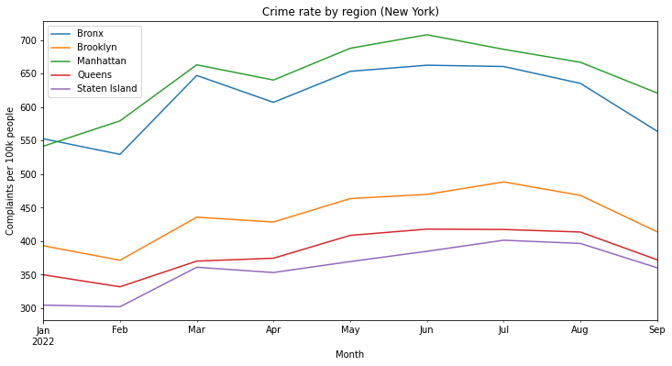

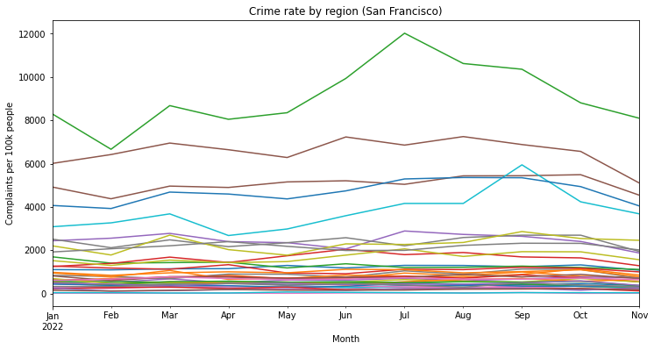

We see that the trends in crime rate over time are similar for each New York borough. For San Francisco, we again note that the crime rates (in this case, monthly) for some regions are unrealistically high and should be regarded with caution.

### 7.3. Zillow Home Value Index

Next, we examined housing prices as a factor in our regression model. To measure housing prices, we used the Zillow Home Value Index (ZHVI), which provides a “smoothed, seasonally adjusted measure of the typical home value” for all homes in a given geographic region and month. For New York, these regions correspond to specific neighborhoods, not boroughs. Thus, from now on, we will use “neighborhoods” unambiguously to refer to each city’s regions.

Similar to our crime rate analysis, we associated each listing with a ZHVI based on the listing’s neighborhood and month of last review. We omitted listings whose neighborhoods did not have an associated ZHVI or month. (The resulting listings range from 2011 to September 2022.) The resulting distributions of ZHVIs over time and among neighborhoods for both cities are shown in the figure below.​

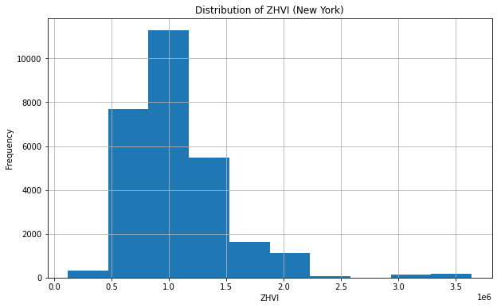

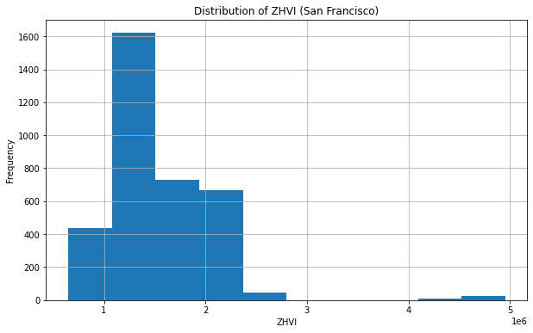

Note that ZHVI is generally higher in New York, reflecting more expensive housing. Notably, in both cities, there is a gap in the middle, which represents the divide between lower/middle-class and affluent neighborhoods.

We used these values of ZHVI as our home value feature in our regression models.

### 7.4. Trivago Hotel Price Index

Finally, we investigated hotel prices as a factor in our regression model. To measure hotel prices, we used the Trivago Hotel Price Index (THPI), which represents hotel prices for a certain city and month. The Trivago data was limited in that it did not include any geographic classifications (e.g. borough, neighborhood), so we were only able to obtain the overall THPI values in New York and San Francisco for each of the past 12 months, which is shown in the figure below.

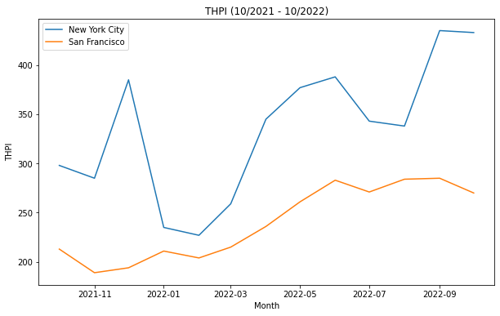

Note that, like ZHVI, the THPI is higher in New York, reflecting more expensive hotels. This makes sense given that there should be some kind of correlation between housing prices and hotel prices.

Similar to our previous analyses, we associated each listing with a THPI based on the listing’s month of last review. However, we do not expect this feature to be reliable, since we have only used the date to match listings to THPIs, not any further specifications like borough or neighborhood. We used these values of THPI as our hotel price feature in our regression model.

### 7.5. Regression Analysis

In the previous three sections, we have engineered the following features:

* Crime rate (“crime_rate_100k”): Number of complaints per 100,000 people for a specific region and month (January 2022 to September/November 2022)
* Home value (“zhvi”): ZHVI for a specific neighborhood and month (May/September 2011 to September 2022)
* Hotel price (“hotel_index”): THPI for a specific month (October 2021 to October 2022)

To perform regression with these features, we filtered the listing data to those with non-null values for all three features, which restricted the time range from January 2022 to September 2022.

We also considered the listing price (“price”) as an additional feature, since we expect there to be some relationship between price and the other three features (especially ZHVI and THPI) and hope that price can explain some of the variation that might have otherwise been attributed to these other features. This is the only feature from the direct model (i.e. listing-specific feature) that we have incorporated into this new regression model for external factors.

With these four features, we performed a regression analysis on our two dependent variables: average overall review score and average location review score. The results for the overall (left) and location (right) scores for New York are shown in the figure below.

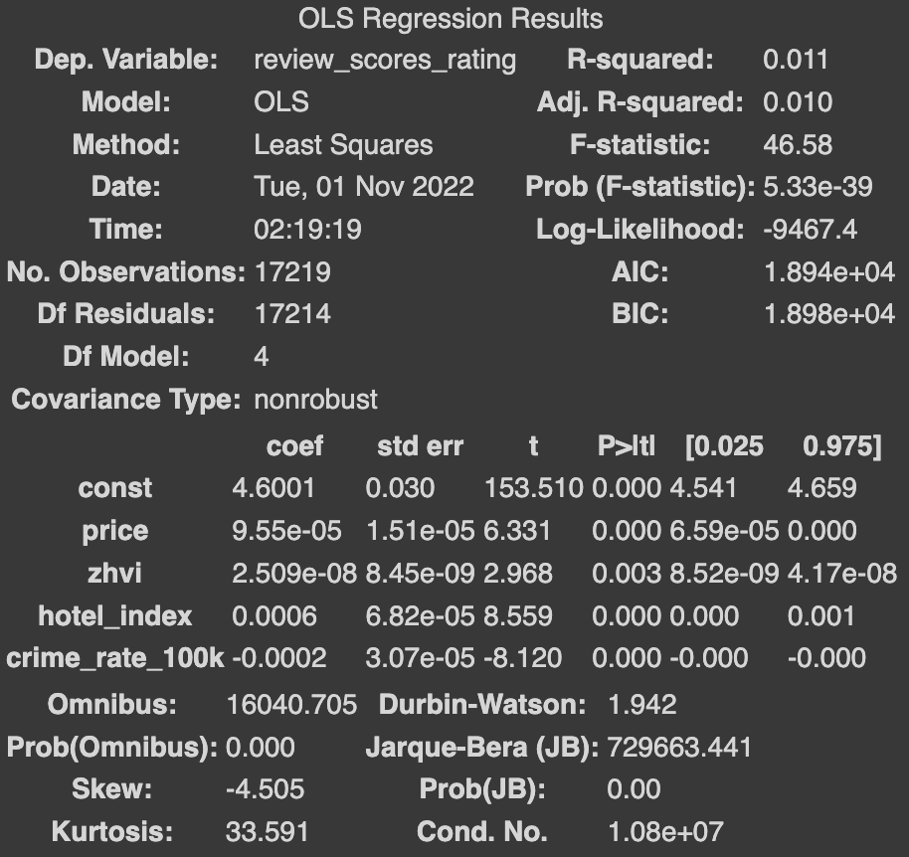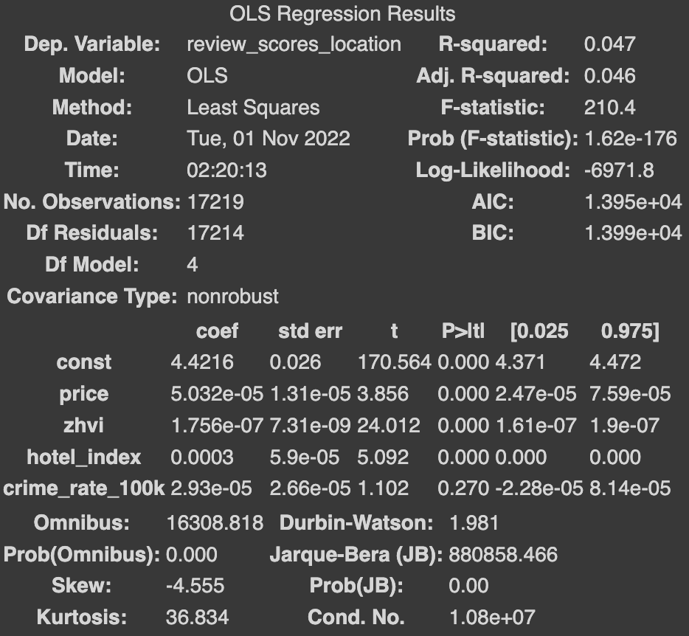

We see that price, ZHVI, and THPI are all significant features that are positively correlated with review score, which supports our hypothesis that listings that are either more expensive or located in areas with higher housing/hotel prices tend to have more favorable review scores. We note that the ZHVI is particularly significant in the location score model. Moreover, the intercept is high (i.e. between 4.4 and 4.6) in both models, indicating that Airbnb users already tend to give high review scores before we consider the effects of the features.

We found a different effect, however, for the crime rate. In the overall score model, the crime rate was significant but negatively correlated with review score, which supports our hypothesis that listings in higher-crime areas tend to receive less favorable reviews. On the other hand, in the location score model, the crime rate was not a significant feature, which did not match our expectation of a relationship between crime rate and location.

The results for the overall (left) and location (right) scores for San Francisco are shown in the figure below.

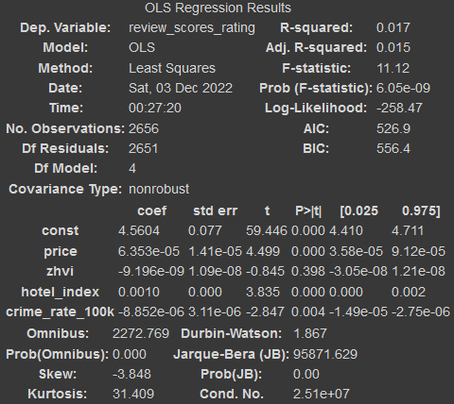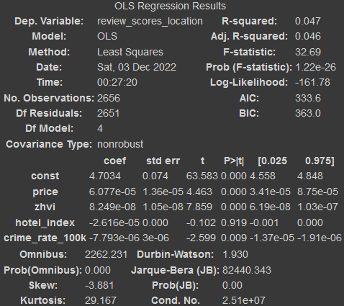

Unlike the New York models, ZHVI is not a significant feature in the overall score model, whereas THPI is not a significant feature in the location score model. The remaining features (except crime rate) are positively correlated with review score, which again supports our hypothesis. We again note that the ZHVI is particularly significant in the location score model. Crime rate was significant but negatively correlated with review score, which again supports our hypothesis that listings in higher-crime areas tend to receive less favorable reviews.

We see that both cities exhibited similar R-squared values for the same dependent variable. We would like to note that these models exhibited weak correlation (R-squared below 0.05), which may be because there are many other factors that were not considered. However, they still give us a general idea of the trends and relationships between the external factors we considered and the review scores of the listings.

## 8. Combined Model

Having engineered sentiment analysis features and external factor features for our direct and external models, respectively, we then decided to combine these two models into overall models for New York and San Francisco. To do this, we merged (for each city) the two listings datasets corresponding to the two models.

We would like to note that this drastically reduced the size of our final datasets compared to the original datasets. This is because (1) we were already working with a small subset (15%) of the original listings data when constructing the direct model and (2) we already reduced the listings data for the external model to only include those that had consistent, non-null information for crime rate, ZHVI, and THPI. As a result, we ended up with 912 and 213 listings for New York and San Francisco, respectively. (For reference, there were originally 39,881 and 6,629 listings, respectively, so our final datasets only included ~2-3% of the original listings.)

With the combined features, we again performed a regression analysis on our two dependent variables: average overall review score and average location review score. The results for the overall (Figure 1) and location (Figure 2) scores for New York are shown in the appendix. Also shown in the appendix are the results for the overall (Figure 3) and location (Figure 4) scores for Chicago.

Again, the R-squared values in these models (between 0.18 and 0.3) are quite low, so we focus on using these models for exploratory purposes (i.e. interpreting the coefficients and the corresponding relationships) instead of predictive purposes.

Having combined features from the direct and external models, we now see that many of these features are no longer significant, suggesting that they have overlapping effects. The table below provides the top three most significant features for each of the four top models, as well as their sign (+ or -).

| ***City ↓, Model type →*** | **Overall score** | **Location score** |
| --- | --- | --- |
| **New York** | amenities (+)  instant_bookable (-)  comment_polarity (+) | zhvi (+)  accommodates (-)  comment_polarity (+) |
| **San Francisco** | availability_365 (-)  calculated_host_listings_count (-)  price (+) | zhvi (+)  calculated_host_listings_count (-)  price (+) |

We see that there are some notable similarities between some of the models:

* “comment_polarity” was significant in both New York models.
* “calculated_host_listings_count” and “price” were significant in both San Francisco models.
* “zhvi” was significant in both location models.

This last result is particularly interesting to us, as it suggests that the positive correlation with home value may be an effect observed across multiple cities - that is, people across these cities tend to leave higher ratings in areas with more expensive housing. Again, this may be because rentals in such areas are considered by renters to be “nicer” and higher-quality.

## 9. Conclusion

In this project, we have attempted to explain the quality of short-term rental listings by using the average ratings (overall and location) given by Airbnb users as a proxy and by constructing regression models based on (1) listing-specific and sentiment analysis features, (2) external features, i.e. local crime rate, home value, and hotel value, and (3) a combination of the two. The latter two categories of models were constructed for two specific US cities - New York and San Francisco.

In all models, the R-squared value was low (at most 0.3). However, the coefficients of the features still support many of our hypotheses. Higher overall ratings were generally correlated with comment polarity (positively), comment subjectivity (positively), hotel value (positively), and crime rate (negatively), in addition to some of the original features. Higher location ratings were generally correlated with home value (positively), which was universally the most significant feature.

Thus, our results have given us an idea of what kinds of features could help explain the rating that a renter gave for a listing and thereby the quality of that listing. For example, listings with higher overall ratings tend to have comments that are more positive and subjective, which may be largely due to renters expressing their satisfaction. As another example, listings with higher location ratings tend to be located in areas with high home value, which may be because home value acts a proxy for neighborhood affluence/quality, and renters are more satisfied with listings in these “nicer” neighborhoods.

Since our project was more exploratory in nature (i.e. focused on finding predictors that explain the ratings well), a natural next step would be to construct predictive models. However, while we did not incorporate predictive modeling into our project, we did see that the R-squared values for our regression models were fairly low, suggesting that it may be difficult to find effective models anyways (at least with the features we worked with). Nevertheless, given more time, we would have liked to try out some other regression models and see if they encountered similar difficulties in predicting listing quality.

## 10. References

1. The history of short-term rentals. Keycafe Blog. (2022, March 30). Retrieved September 27, 2022, from https://blog.keycafe.com/the-history-of-short-term-rentals/
2. Deane, S. (2022, July 29). 2022 airbnb statistics: Usage, demographics, and revenue growth. Stratos Jet Charters, Inc. Retrieved September 27, 2022, from https://www.stratosjets.com/blog/airbnb-statistics/
3. Airbnb. (2022). Get the Data. Inside Airbnb: Adding data to the debate. Retrieved September 27, 2022, from http://insideairbnb.com/get-the-data

## 11. Appendix

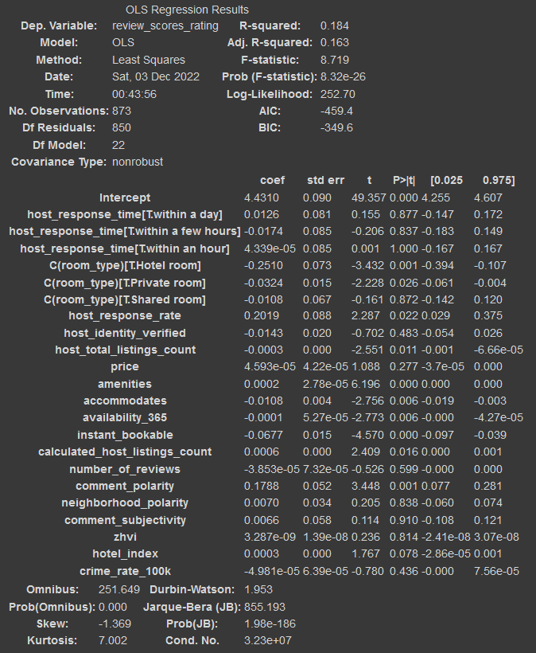

**Figure 1: Regression results for New York (overall score)**

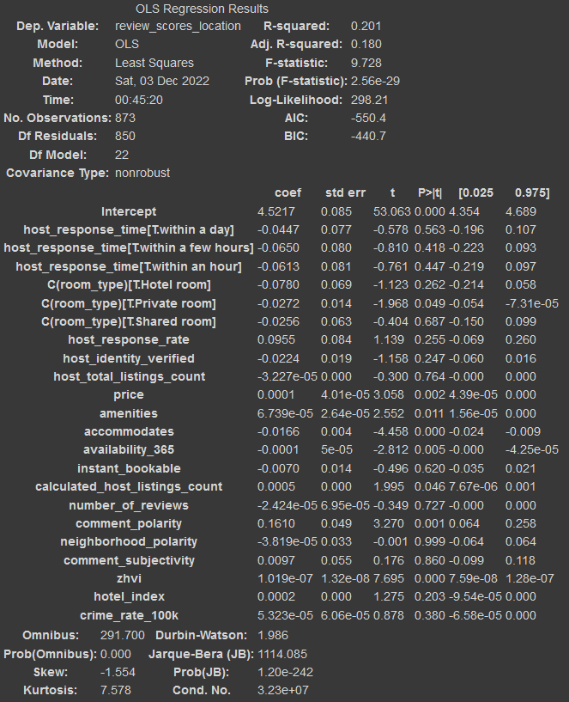

**Figure 2: Regression results for New York (location score)**

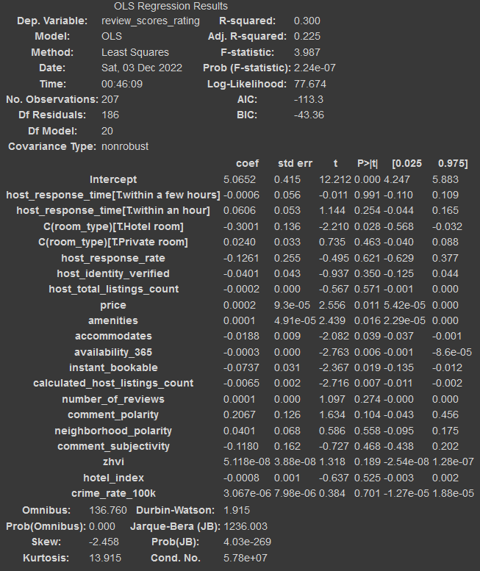

**Figure 3: Regression results for San Francisco (overall score)**

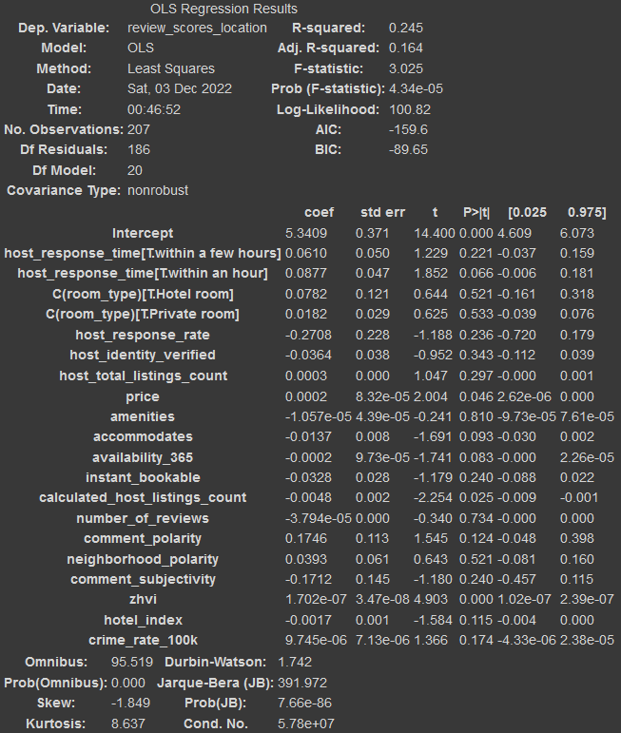

**Figure 4: Regression results for San Francisco (location score)**